Regeneration Generation: Treatments for sports injuries and arthritis
Jan 20, 2015
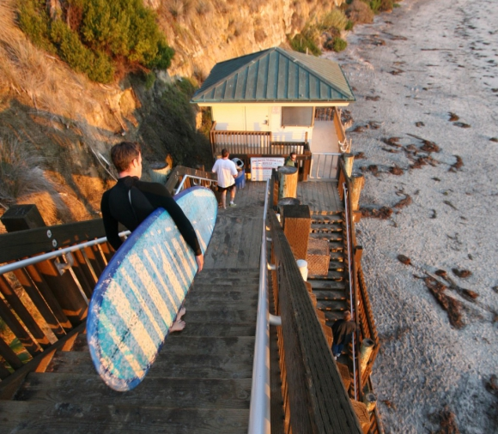If you’re suffering from arthritis or a sports injury there are multiple exciting treatments, including stem cell therapy and platement rich plasma treatments to help you get back to your peak performance levels.
We are the “regeneration generation.” The renaissance in healing happening around us is led by regenerative and stem cell medicine. Headlines are exploding with news — the 3D printing of a functional liver, small bags of islet cells implanted under the skin to treat diabetes, stem cells used for accurate drug delivery to target brain cancer.
It truly is an exciting time. Many with sports injuries and arthritis are surprised to discover the wealth of regenerative treatments currently available to them.
The recent research is stunning—many regenerative treatments have been shown to heal partially torn ligaments, regrow cartilage, stabilize joints, decrease inflammation and pain, and improve function, all without surgery or prolonged recovery times.
A former NIH fellow, Dr. Alexandra Bunyak is focused on bringing this emerging research to her patients. She is quadruple board certified in Sports Medicine, Physical Medicine and Rehabilitation, Holistic Medicine, and Pain Medicine. She trained at Yale, the University of Pennsylvania, and Northwestern’s Rehabilitation Institute of Chicago.
Dr. Bunyak founded BOUNDLESS in Encinitas in 2006 to offer innovative, ultrasound and fluoroscopy-guided injection therapies that boost patients’ own healing powers naturally. Her laboratory background enables her to personalize hand-crafted therapies for optimum success for each patient. “As an athlete, martial artist, and physician living in Encinitas, my goal has always been to help my patients enjoy our region’s endless summers, outdoor sports, and stunning coastlines, regardless of their age. The new advances in regenerative medicine bring this goal within reach.”
The three main categories of regenerative treatments available for sports injuries and arthritis include: Prolotherapy: Dating back 2,500 years, prolotherapy is the purposeful stimulation of the body’s innate capacity to heal wounds and repair injured tissues. In this treatment, dry needling and injection of a variety of solutions (hypertonic dextrose, hormones, and inflammatory agents) stimulate the areas that need repair to start the healing cascade. Platelet Rich Plasma (PRP): This treatment involves the injection of concentrated platelets and growth factors—as collected from your blood during an in-office procedure—into an area of injury or arthritis. The growth factor concentrate signals local cells to replace the injured area with healthy tissue.
Stem Cell Therapies: Mesenchymal stem cell therapy deposits stem cells, growth factors (PRP/platelet lysate), and supportive cells locally at the site of damage or arthritis, or intravascularly for delivery to distant organs and nerves. Mesenchymal stem cells are known to differentiate into cartilage, bone, muscle, ligament, and nerve cells; control inflammation; and attract other stem cells and growth factors to the injured area.
This therapy is used when more effective healing of a severely injured region or more advanced arthritis is desired, and is considered the current state-of-the-art in regenerative therapy. Dr. Bunyak will be speaking about these therapies and recent research advances at her upcoming talks:
“Regenerate Your Health in the New Year” This regenerative medicine overview talk, followed by a Q&A, will range from herbs to stem cells and everything in between. Solana Beach Library, Library Chat, Jan. 20, 6:30 p.m.
“Regeneration Generation: Innovative Therapies for Sports, Spine, and Arthritis Care” This talk will focus more deeply on the three therapeutic approaches of prolotherapy, PRP, and stem cells. Rancho Santa Fe Library, Jan. 22, at 11 a.m. Visit feelboundless.com or call (760) 632-1090 to learn more.

